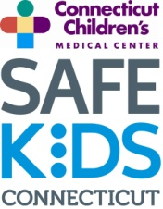
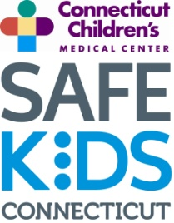
Safe Kids Connecticut Membership Application
Please return this form to Meg at mmccabe@connecticutchildrens.org or return form to:
Safe Kids Connecticut
282 Washington St.
Hartford, CT 06106
Name: Title: ,
Organization: ,
Address: ,
City: State: Zip Code: ,
Telephone: Fax: ,
E-mail :, ,

I can help Safe Kids Connecticut by:
□ Attending coalition meetings
□ Volunteering for events (or providing volunteers from my organization)
□ Supporting activities with donations or fundraising
□ Hosting or sponsoring a Safe Kids Connecticut event or program

Are you interested in receiving the Safe Kids Connecticut e-newsletter?
□ Yes □ No
Are you interested in working in a specific coalition?
□ Safe Kids Fairfield County □ Safe Kids Windham County □ Safe Kids New London County
□ Safe Kids Litchfield County □ Safe Kids Greater Naugatuck Valley □ Safe Kids Greater New Haven
□ Safe Kids Greater Waterbury

Are you interested in leading a Safe Kids Coalition in your area?
□ Yes □ No

,
Signature Date

Like us on Facebook! https://www.facebook.com/SafeKidsCT

